Phase 3: Implementation of Project

Title: AI-Powered Supply Chain Management System

Objective

The goal of Phase 3 is to implement the core components of the AI-powered supply chain management system, based on the plans and innovative solutions developed during Phase 2. This includes the development of AI-powered demand forecasting, chatbot interface for supply chain inquiries, initial IoT integration, and the implementation of data security measures.

# AI Model Development for Demand Forecasting

Overview

The primary feature of the AI-powered supply chain management system is its ability to predict demand and optimize the supply chain. In Phase 3, the AI model will be trained to analyze historical data and forecast demand for products, which will aid in inventory management and order planning.

Implementation

* Machine Learning Model: The AI system uses machine learning techniques to analyze past sales, trends, seasonality, and other relevant factors to predict future demand. In this phase, the AI will focus on generating basic demand forecasts for commonly ordered items.
* Data Source: The model will use historical sales data, seasonal trends, and promotional events to forecast demand. Real-time data will not be integrated at this stage but will be added in future phases.

Outcome

By the end of this phase, the AI model should provide basic demand forecasts for key products, helping supply chain managers plan inventory and adjust supply orders to match predicted demand.

# Chatbot Development for Supply Chain Queries

Overview

The AI-powered supply chain management system will be made accessible through a chatbot interface, allowing users (e.g., warehouse managers, inventory staff) to ask questions related to supply chain performance, inventory levels, and demand forecasts.

Implementation

* User Interaction: Users interact with the chatbot through a simple text-based interface, asking questions like "What is the predicted demand for product X this month?" or "What is the current inventory level for product Y?"
* Language Support: The chatbot will initially support English, with future plans for additional languages and voice-based interactions.

Outcome

By the end of Phase 3, the chatbot will be functional, providing users with key supply chain insights based on user queries. It will offer an intuitive interface to interact with the AI and receive timely, data-driven responses.

# IoT Integration for Real-Time Data

Overview

While IoT integration is optional for this phase, the goal is to establish basic connections between the AI-powered supply chain system and IoT devices (e.g., smart inventory tracking devices, RFID tags, or smart warehouse systems) to enable the collection of real-time data for enhanced decision-making.

Implementation

* Real-Time Data Collection: If available, data from IoT devices like smart shelves, inventory sensors, or GPS trackers will be integrated into the system to provide real-time updates on inventory levels, delivery status, and product conditions.
* API Use: APIs provided by IoT device manufacturers (e.g., RFID or inventory management systems) will be utilized to gather real-time data.

Outcome

By the end of Phase 3, the system should be able to collect basic real-time data from connected devices, providing more accurate and timely insights for supply chain management. This functionality will be enhanced in future phases as more IoT devices

are integrated.

# Data Security Implementation

Overview

Given the sensitive nature of supply chain and business data, it is crucial to implement robust security measures. In Phase 3, the focus will be on securing sensitive data, including inventory information, vendor details, and transaction records.

Implementation

* Encryption: All sensitive data (including sales, inventory, and vendor details) will be encrypted using secure encryption methods.
* Secure Storage: Data will be stored in a secure, encrypted database, ensuring that only authorized personnel can access critical business information. The system will adhere to relevant data privacy regulations (e.g., GDPR).

Outcome

At the end of Phase 3, the AI system will securely store and handle all supply chain data, with robust encryption and security measures in place to protect against unauthorized access.

# Testing and Feedback Collection

Overview

Initial testing of the AI-powered supply chain management system will be carried out to evaluate its performance, accuracy, and user experience.

Implementation

* Test Groups: A small group of supply chain managers, warehouse staff, and logistics personnel will test the system, inputting data related to inventory levels, demand forecasting, and supply chain performance to see how the AI system responds.
* Feedback Loop: Feedback will be gathered on the accuracy of demand forecasts, the usability of the chatbot interface, and the effectiveness of real-time data from IoT devices.

Outcome

The feedback gathered during Phase 3 will guide improvements in Phase 4, particularly in refining the AI’s forecasting accuracy and improving the chatbot’s interface.

# Challenges and Solutions

1. Model Accuracy
   1. Challenge: The AI may generate inaccurate demand forecasts due to limited data or incorrect assumptions about market trends.
   2. Solution: A continuous feedback loop will be established, and the AI will be regularly retrained using updated data to improve its accuracy over time.
2. User Experience
   1. Challenge: The chatbot interface may require refinement to make it more intuitive and user-friendly for supply chain personnel.
   2. Solution: User feedback from the testing phase will be used to improve the chatbot's interface and functionality, ensuring a more seamless experience for users.
3. IoT Device Availability
   1. Challenge: The availability of IoT devices may be limited during this phase, which could hinder the real-time data collection process.
   2. Solution: Simulated data will be used in the short term to demonstrate the capability of the system to handle real-time data, while further integration with IoT devices will be planned for future phases.

# Outcomes of Phase 3

By the end of Phase 3, the following milestones should be achieved:

1. Basic AI Model for Demand Forecasting: The AI system should be able to generate demand forecasts for key products based on historical data.
2. Functional Chatbot Interface: A functional chatbot will be in place, allowing users to interact with the AI system and receive relevant insights related to inventory and demand.
3. Optional IoT Integration: If IoT devices are available, the AI system will be able to collect real-time data such as inventory levels and product conditions.
4. Data Security: All supply chain data will be securely stored and encrypted, with protections in place to prevent unauthorized access.
5. Initial Testing and Feedback: Feedback will be collected from early users to identify areas for improvement and refine the system for Phase 4.

# Next Steps for Phase 4

In Phase 4, the team will focus on:

1. Improving AI Accuracy: Leveraging feedback and real-world data to refine the demand forecasting model and increase its accuracy.
2. Expanding System Capabilities: The chatbot will be expanded to support additional languages, voice commands, and more advanced supply chain queries.
3. Full IoT Integration: The system will fully integrate with a broader range of IoT devices to provide comprehensive, real-time data for supply chain management.
4. Scalability and Optimization: The system will be optimized to handle larger volumes of data, larger numbers of users, and more complex supply chain

scenarios.

Sample Coding (Python)

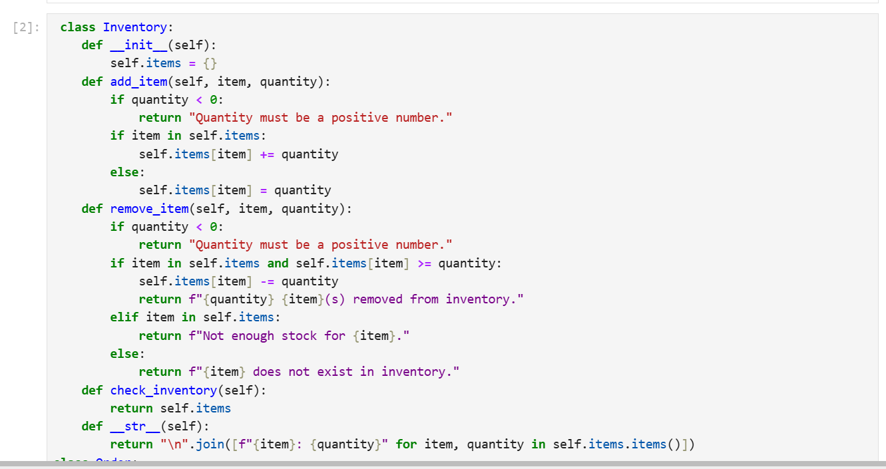

Output: